Logistic Regression
Before starting with the algorithms lets understand two important terms that we are going to use in all the algorithms going forward
Training Set:
This portion of the data is used to train a machine learning model. The model learns patterns and relationships within this data to make predictions.
Testing Set:
This separate portion of the data, which the model has not seen during training, is used to evaluate the model's performance and generalization ability. By testing the model on unseen data, it is possible to assess how well it can predict outcomes on new, real-world examples.

What is Logistic Regression?
Logistic Regression is a supervised learning algorithm used mainly for binary classification problems. Despite the name, it is used for classification, not regression.

What Problem Does Logistic Regression Solve?
It predicts the probability that an input belongs to a certain class.
Example problems:
- Spam vs Not Spam
- Fraud vs Legit
- Disease vs No Disease
- Malware vs Benign
Output is usually:
- 0 or 1
- False or True

Why It’s Called “Logistic” Regression
Instead of predicting a continuous value (like linear regression), it applies a logistic (sigmoid) function to map values between 0 and 1

How Logistic Regression Works
Step 1: Linear Combination
First, it computes a linear equation:
$$z=w_{1}x_{1}+w_{2}x_{2}+...+w_{n}x_{n}+b$$
Where:
- $x$= input features
- $w$= learned weights (It learns these weights while training)
- $b$= bias

Step 2: Sigmoid Function
The result is passed through the sigmoid function:
$$σ(z)=\frac{1}{1+e^{-z}}$$
This converts any number into a value between 0 and 1, interpreted as probability.

Step 3: Decision Boundary
- If probability ≥ 0.5 → Class 1
- If probability < 0.5 → Class 0

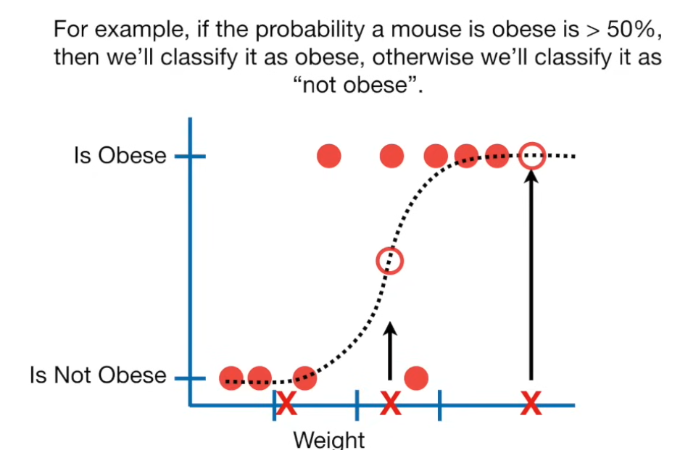
9. Advantages
✅ Simple and fast
✅ Easy to interpret
✅ Outputs probabilities
✅ Works well for linearly separable data

10. Limitations
❌ Cannot model complex non-linear relationships
❌ Sensitive to outliers
❌ Requires feature engineering

Why Is the Graph S-Shaped?
Because logistic regression applies the sigmoid function:
$$p=\frac{1}{1+e^{-z}}$$
Behavior of the curve:
- Very small z (negative) → probability ≈ 0
- Very large z (positive) → probability ≈ 1
- z = 0 → probability = 0.5
This creates a smooth S-shaped curve.

How Are Weights (w) and Bias (b) Determined?
They are learned by minimizing the loss (log loss) using an optimization algorithm called Gradient Descent.

Step-by-Step Explanation
1️⃣ Start with Random Values
- Weights $w_{1},w_{2},...,w_{n}$and bias $b$start as small random numbers
- Model initially makes poor predictions (that’s okay)

2️⃣ Forward Pass (Prediction)
For each training example:
- Compute linear combination:
$$z=w⋅x+b$$
- Apply sigmoid:
$$p=σ(z)=\frac{1}{1+e^{-z}}$$
This gives the predicted probability

3️⃣ Compute Loss (Error)
Using log loss:
$$Loss=-[ylog⁡(p)+(1-y)log⁡(1-p)]$$
This tells us how wrong the prediction is.

4️⃣ Gradient Descent (Key Step 🔥)
We calculate:
- How much the loss changes w.r.t each weight
- How much the loss changes w.r.t bias
This is done using partial derivatives:
$$\frac{∂Loss}{∂w},\frac{∂Loss}{∂b}$$
These gradients tell us:
“Which direction should we move the weights to reduce the loss?”

5️⃣ Update Weights and Bias
Weights and bias are updated using:
$$w:=w-α\frac{∂Loss}{∂w} \\ b:=b-α\frac{∂Loss}{∂b}$$
Where:
- $α$= learning rate (step size)

6️⃣ Repeat (Training Loop)
- Steps 2–5 are repeated for many iterations (epochs)
- Loss keeps decreasing
- Weights converge to optimal values

